Presentation

Common Points: - Please Increase Font Size

Now Divisions will be 6 instead of 5

Sequence would be -
Manah Dynamics
Manah Green Energy
Manah Atomic
Manah Aerospace
Manah AI
Manah Investments
---
Manufacturing part of dynamics
Manah Atomic
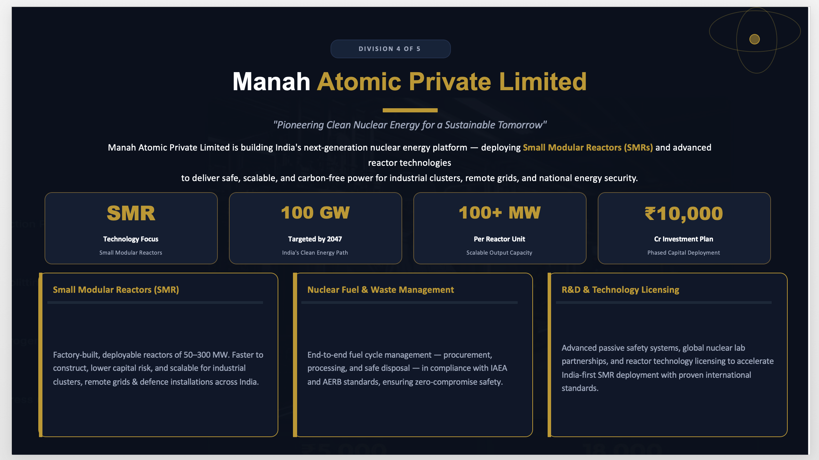

Also sending a presentation where changes made included please follow that and change as per below comments
---
Slide 1:

Please change the word technology to Atomic under A from Manah
---
Slide 4: Group Structure

Update Division - Manah AI from "Tech & Manufacturing"

Manufacturing will be part of Manah Dynamics, AI and Data Centers comes under Manah AI

add another company Mana Atomic
Mana Atomic - Nuclear Energy Solutions
• Small Modular Reactors (SMR)
• Advanced nuclear fuel cycle
• Reactor safety & compliance
• Clean energy transition

Division Sequence to be followed
---
Slide 8:
Ongoing Projects (Updated List)
# | Project | Client | Sector
1 | Construction of Four G+4 Residential Buildings | MES | Civil
2 | Supply & Installation of 48,893 DTC Meters (6 Districts) + 5-Yr Maintenance | HESCOM | Power / Metering
3 | Construction of 400/220 KV GIS Substation | PGCIL, Roorkee | Power Transmission
4 | Construction of Transmission Line & Towers - 400/220 KV GIS Substation | PGCIL, Roorkee | Power Transmission
5 | Construction of Conveyor system | Morocco | Industrial Infra
6 | Construction & Development of Commercial complex | Singrauli, MP | Real Estate
7 | Development of Middle Mile Network on DBOM Basis | BharatNet | Telecom / Infra
8 | Construction G+17 Building in Mumbai | Terna Trust | Civil
9 | Construction of G+2 Building in ahilyanagar | MES | Civil
10 | Construction of 5G Towers in 6 states | BSNL | Telecom / Infra
11 | Construction of Ambhaji Railway Station | NWR | Civil

---
Slide 10:
Pipeline Projects (Update slide data)
# | Category | Description | Status
1 | M&A | Due Diligence of Product & EPC Companies for 3 Potential Mergers & Acquisitions | Strategic
2 | EPC Bids | EPC Works Being Pursued via Bids in Domestic & International Markets | Active Bidding
3 | Investments | Investments Under Planning & Execution Across Key Infrastructure Sectors | Under Planning
4 | HAM Projects | Hybrid Annuity Model Projects Under Bidding at Domestic Level | Under Bidding

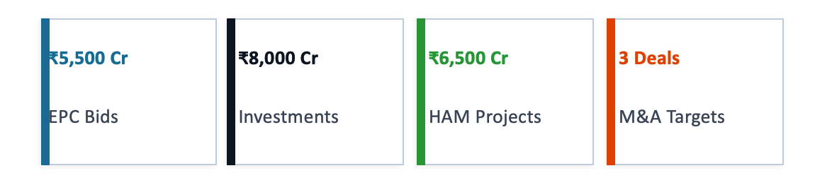
Combined Pipeline Opportunity: ₹20,000+ Crores | Domestic & International Markets
---
Slide 12:
Manah Aerospace

Please change Aircraft Serviced 10+ to Providing MRO Services to 18+
---
Slide 13: MRO Services

Remove slide
---
slide 14 : Certifications & Capabilities
Remove slide

---
slide 15 : Aerospace Growth Map
Update “4 current locations + 4 planned expansions across India”
- 6 current locations (add Chennai and Bangalore)
- 2 planned expansions (Pune and Kolkata only)
----
Slide 16 : Manah Green Energy

- Remove “Sohhytec” as technology partner and mention like different technology partners

- change “ARB” based tech to “ARB and electrolysis” type
-----
Slide 17 (Green H₂ Progress)
Accordingly please change slide no. 17
MoU & Agreement
Signed with Government of Madhya Pradesh for Hydrogen Production Plant at Bina, based on ARB (Artificial Photosynthesis) Technology
Technology Partnership
Strategic partnership with SoHHytec SA, Switzerland for water-splitting Artificial Photosynthesis technology
- Update
Remove “Sohhytec” as technology partner and mention like different technology partners

- change “ARB” based tech to “ARB and electrolysis” type

---
Slide 18 :
Rewrite this slide as per new Division Mapping. And Naming.
Remove Division number, here manah atomic will come as shown in the presentation and move this slides to dynamics division all of this slides should be shown before our projects. please align it accordingly
---
Slide 25:
Strategic Partnerships
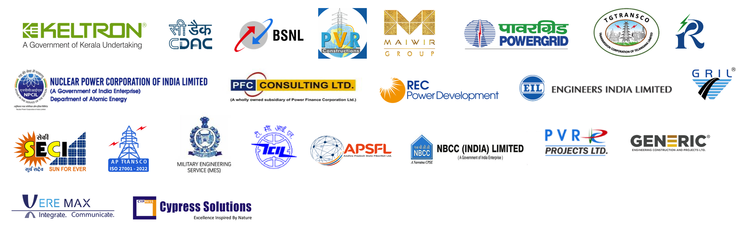

Please change as shown in the presentation
---
Slide 26: Future Expansions

Please see there are some common sectors mentioned like in slide 6. please remove it accordingly
---
Slide 29: Our Presence

Please add locations

Vishakapatnam - Regional Office

Madhya Pradesh - regional office - Bhopal

Bangalore - Regional office

